Software Development Life Cycle

A software development process, also known as a software development life cycle (SDLC), is a structure imposed on the [development of a software product](http://en.wikipedia.org/wiki/Software_development). There are several [models](http://en.wikipedia.org/wiki/Software_development_process#Software_development_models) for such processes, each describing approaches to a variety of [tasks or activities](http://en.wikipedia.org/wiki/Phases_of_the_software_development_cycle) that take place during the process.

Waterfall Model

The approach used in this project for software development is 'The Waterfall Model'. In the waterfall approach, the whole process of software development is divided into separate phases. These phases in the model are:

1. Requirement specifications phase
2. Software design
3. Implementation
4. Testing and maintenance

All these phases are cascaded to each other so that the second phase is started as and when a defined set of goals are achieved for first phase and it is signed off and hence the peculiar name. All the methods and processes undertaken in the model are more visible.

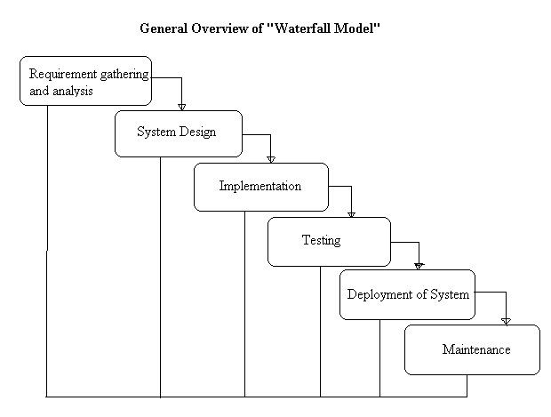

The project requirements are very well known, clear and fixed. There are no ambiguous requirements. Similarly, technology used is also well known. As every phase is fixed, there is no need of revisiting. This relates to use Waterfall Model.